Ashley Music

5/12/20

Lab 1

BDAT 635 – Advanced Topics in Data Analytics

Configuring neo4j to load a CSV:

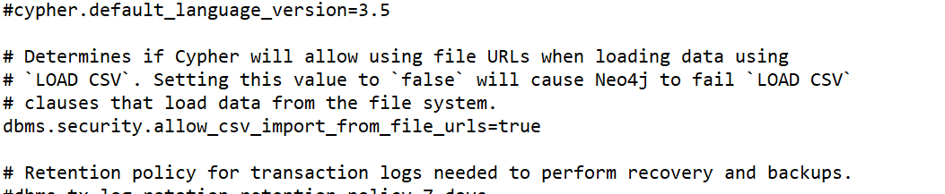

CSV file located in imports folder for neo4j:



Code to load database:

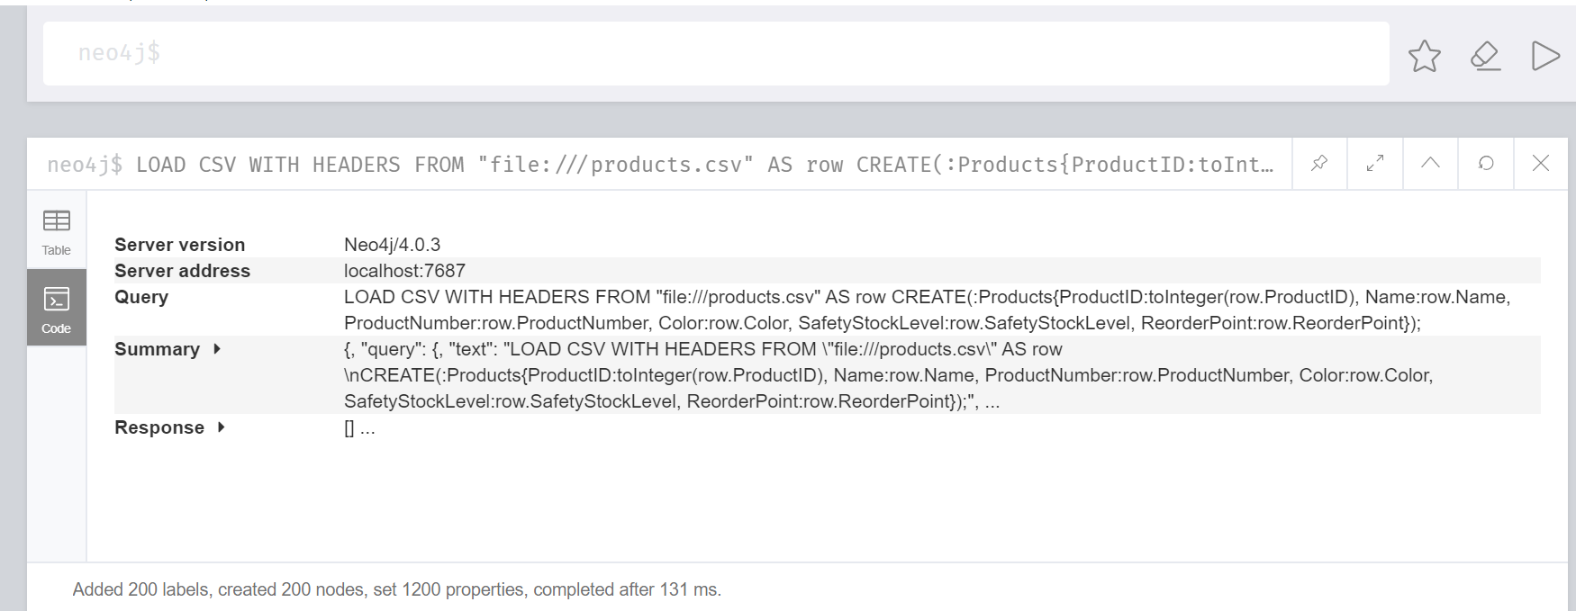

Actual Code:

LOAD CSV WITH HEADERS FROM "file:///products.csv" AS row

CREATE(:Products{ProductID:toInteger(row.ProductID), Name:row.Name, ProductNumber:row.ProductNumber, Color:row.Color, SafetyStockLevel:row.SafetyStockLevel, ReorderPoint:row.ReorderPoint});

Database loaded:

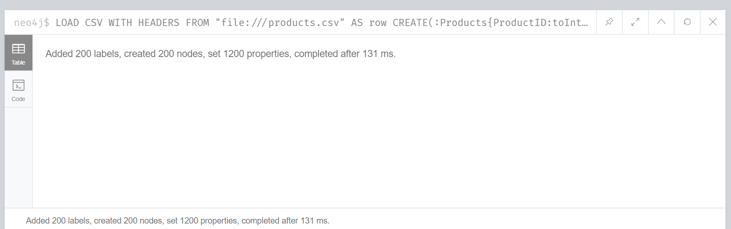

Database Information:

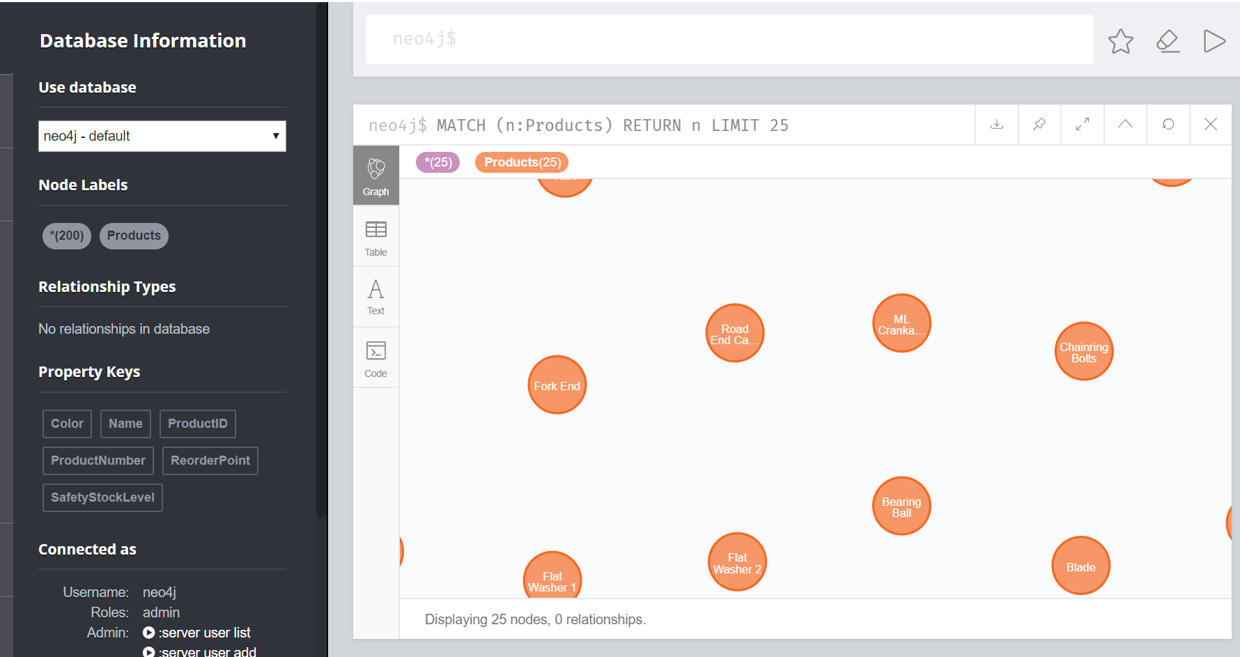

Graph Database for Bike Products:

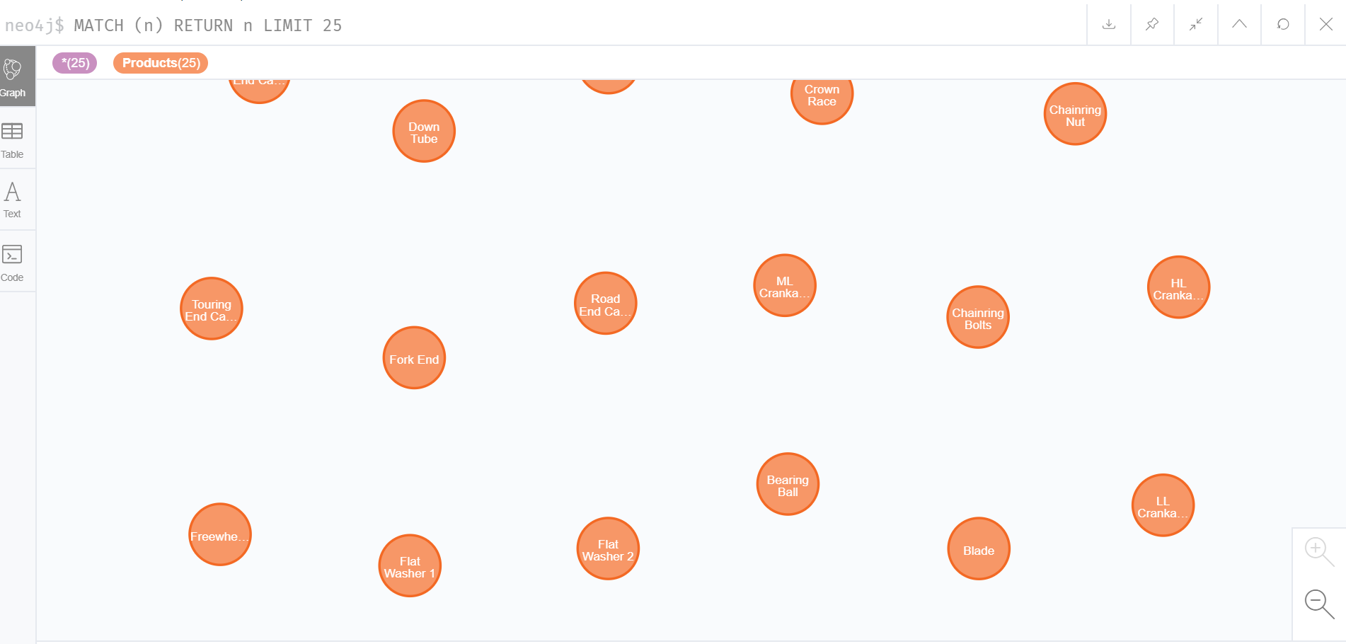

Hovering over the node to show the properties:

